Car Rental System

Process Report

**Students**

Rares Dumitru Bunea: 266983

Anatoli Dunai 269643

Vladiimir Rotaru 266814

**ICT Engineering, VIA University College, Horsens**

Table of Contents

1 Introduction 3

2 Group Description 4

2.1 Embedded engineering 4

2.2 Data 4

2.3 Android development 4

3 Project Initiation 5

4 Project Description 6

5 Project Execution 7

6 Personal Reflections 8

6.1 Android Team 8

6.2 IOT Team 9

6.3 Data Team 10

7 Supervision 11

8 Conclusions 11

# 1 Introduction

This paper is meant to inform both the team and the reader about how the planned activities worked out and how the collaboration and workflow went in our group for this project.

For this project, the topic for this assignment was freely chosen by us.

The chosen framework for this project was Unified Process. This method was chosen because, since the project was made during the summer holiday, regular sprint meetings couldn’t be held at the beginning of the project period. Once everybody got back in Denmark, the workflow started to be very organized a productive, with meetings occurring roughly every day (with minor exceptions caused by work or illness), meetings lasting usually around 8 hours (like a regular workday).

One of the major setbacks that was encountered, was that, since this project was made for a reexamination, it was made without any supervision from any teachers. With this being said, it was difficult to find answers to different problems encountered in the process of creating our system.

# 2 Group Description

Our group was initially made from 4 members, but, sadly, because of VIA’s policy, one of our group members was forced to make his project on a different topic that the one chosen by us. He will not be mentioned in this paper.

In this chapter the group members will be described.

## 2.1 Embedded engineering

Alexandru Dima Mircea

Alexandru is a team member of IoT group. Having good will to improve every time, he was a main active part of the team. Since the team encountered many difficulties to move on, Alex struggled to encourage and keep the team together and organized.

Liviu Lesan

Liviu, member of the IoT team. Having skills in evaluation of the necessary requirements for delivering desired final product he took lead part in elaboration period of project. Knowledge that he holds in software engineering made him suitable candidate for designing a part of IoT module. Seeking for solutions unmask the real enthusiasm.

Ionut Boitan

Ionut, member of the IoT team, with skills in analyzing and characterized as an implementer and sharper. With abilities in understanding basic hardware architecture, helped in designing and implementing the FreeRTOS managed data flow. Also, having the focus for details, most of the time it was available and to answer different questions so the rest of the team to move forward, when stuck on errors or understanding.

## 2.2 Data

Alexandru Ciornea

The first member of our Data team is Alexandru. He had a low database knowledge but since he is a colleague of Mihai and Raul, he managed to learn various things about Databases and the tools related to it. Besides that, he is an important member of the team because of his role as ‘documenter’, meaning that while the others were implementing, he was documenting everything.

Alexandru Mihai Serb

Alex is the most database-skilled member of the team. Since he has previously worked in the database field in other school and personal projects, he holds great knowledge on the subject and represented a great asset to our team. He was the main designer of the Database side. When the time was tight, he showed great implication by putting in extra hours of work.

Raul Pologea

Raul is one of the three members of the Database branch of the project. In this project he worked towards achieving the many sub-goals of the team by ensuring that everyone was doing their job and by working himself on the tasks assigned. He believes that no matter how unfavorable the situation may be, a good team coordination will almost always lead to a good result.

## 2.3 Android development

Alexandru Vieru

Alexandru has a previous education in Civil Engineering and has worked in the field of construction for 3 years. During this time, he has gained experience on how to meet deadlines and how to organize a team to reach certain set goals.

After this period, he has moved to Denmark and finished an education in IT Network and Electronics Technology at Business Academy Arhus. During this time, he has gained experience and knowledge on how to write reports in the IT field.

Currently he is enrolled in the ICT education at VIA University to pursue a degree in software development.

He is considered to have high standards when it comes to working for a project and considers himself to be a good team player.

Hard work, determination and never give up once you reach obstacles are his creed.

Dumitru Rares Bunea

Young and enthusiastic, with the urge to learn more and more, Dumitru was happy to work together with people with different ages, learning from the older and sharing the energy with the younger.

Regarding the project, he was assigned to the Cross-media team, working on the Android part of the project, a task he found fit for himself. The previous knowledge gathered in the Java field throughout his studies helped him carry his assignments with ease.

With his way of so called “mathematical” way of thinking he participated in designing, implementing and documenting the system.

# 3 Project Initiation

This chapter will focus on discussing the topic that has been give to this project team from our school. The given assignment focuses on 3 major aspects.

Retrieve sensor data from a room which is in our school.

Send this data to a storage unit using the network provided by our supervisors.

Retrieve the data and make it so that it can be available for a give user that uses an android application.

The group was formed by our supervisors and was not free of choice and the group members where merged from multiple ICT classes.

Our planning for this project went mostly well, for the give assignment. The meetings we had gave us the possibility to communicate with each other about the different stage of the report we were on and asked for help when falling behind.

This gave us a sense of purpose and most where motivated to complete the given tasks to reach the next steps for this project.

Although this sounds perfect in theory most times things do not go as well as the are planned to. Many times, we struggled with completing certain tasks which proved to be more difficult to solve than expected.

Some of these issues where solved at the end while others where not able to complete on time due to a certain team not doing what they promised and signed up to do.

Most of the tasks where accomplished thanks to a strict and well organized regiment which included a risk assessment document which was more to inform the people participating in this project about the given tasks and their set completion time and also about the risks involved if they do not put the required work into them.

A group contract was formed in which we all agreed with the written set of rules and the consequences that will occur if the rules will be broken.

As mentioned before, this works fine in theory but in practice it’s a different story.

While the estimated time had plausible values, the actual time spend on certain tasks took longer than expected thus resulting in the group falling behind schedule.

# 4 Project Description

The problem statement for this project was created based on the case we received from the school. Our costumer required 3 tasks which where critical to accomplish.

First task was to configure a device that would get CO2,humidity and temperature readings from a room inside our school.

The second step was to store these readings into a database which resided on a server on one of the school’s networks.

Lastly, we were asked to create an android application with which users could connect to the database and retrieve the readings which were stored.

Once all the given tasks where clear, we moved forward and created a customer description to better understand what their actual needs and expectations are for this project.

In the delimitation chapter of our problem statement we chose the methodology and the aspects that were most important and relevant for this project and discarded those that were deemed not relevant.

Another key element that was implemented and mentioned before in this document, was our Risk Assessment, where we allocated a grade of importance for the given tasks. This gave us a strong understanding on which of them where considered critical and which were considered less important.

This helped us to better understand the level of involvement for this assignment and practice caution not to break any of the set rules.

# 5 Project Execution

In this part of the report we will discuss how the execution part went and what methods we used to respect the given deadline.

The method used was Unified Process which we considered to be beneficial for our group due to the group not being able to understand and implement SCRUM since the methodology proved to be complex.

By using Unified Process, we divided our time into 4 stages which are Inception, Elaboration, Construction and Testing.

In the Inception part we formed our group after which we generated the project idea and started with our initial planning.

Once the all the tasks from the Inception where completed we moved on into the Elaboration stage of our report.

We first started to create User Stories which were essential to understand what our customer wanted. Upon completion we created the user requirements which where divided based on their importance faction into functional and non-functional requirements.

Based on the functional requirements, we generated a Use Case diagram, which better illustrated what tasks the system should perform.

Use case descriptions where made for the use cases and their task is to explain in more detail each use case and the precondition and post conditions needed for them to function.

Activity diagrams where also made to show the user interaction with the system and how it would behave if certain tasks where executed differently.

A domain model was created which shows how the different elements in our system are tied up and how they communicate with each other.

And finally, system sequence diagrams where created that show the interactions starting points and end points for the different components for the given system.

During the construction phase for this project, the 3 subgroups started working on their own, each establishing their own pace.

During this phase the groups started working on creating conceptual diagrams which gives a clearer understanding on how the code is structured and how different elements form relations with each other. Upon completion a class diagram was created for each of the subgroups, which contained also the logic behind their stage of the system.

Sequence diagrams where also made since they provided a detailed explanation on how the different components interact and communicate with each other.

The final stage of our project is the Testing stage. In this part each team where assigned the actual implementation for the given system.

Some of the teams started on implementing parts of their code and testing it after. If the tested part of the code was successful, then they would move on to the next part of the implementation followed up by other tests.

A burndown chart has been generated as it can be seen bellow, not being a really success, because of the missing data from the database team in due time.

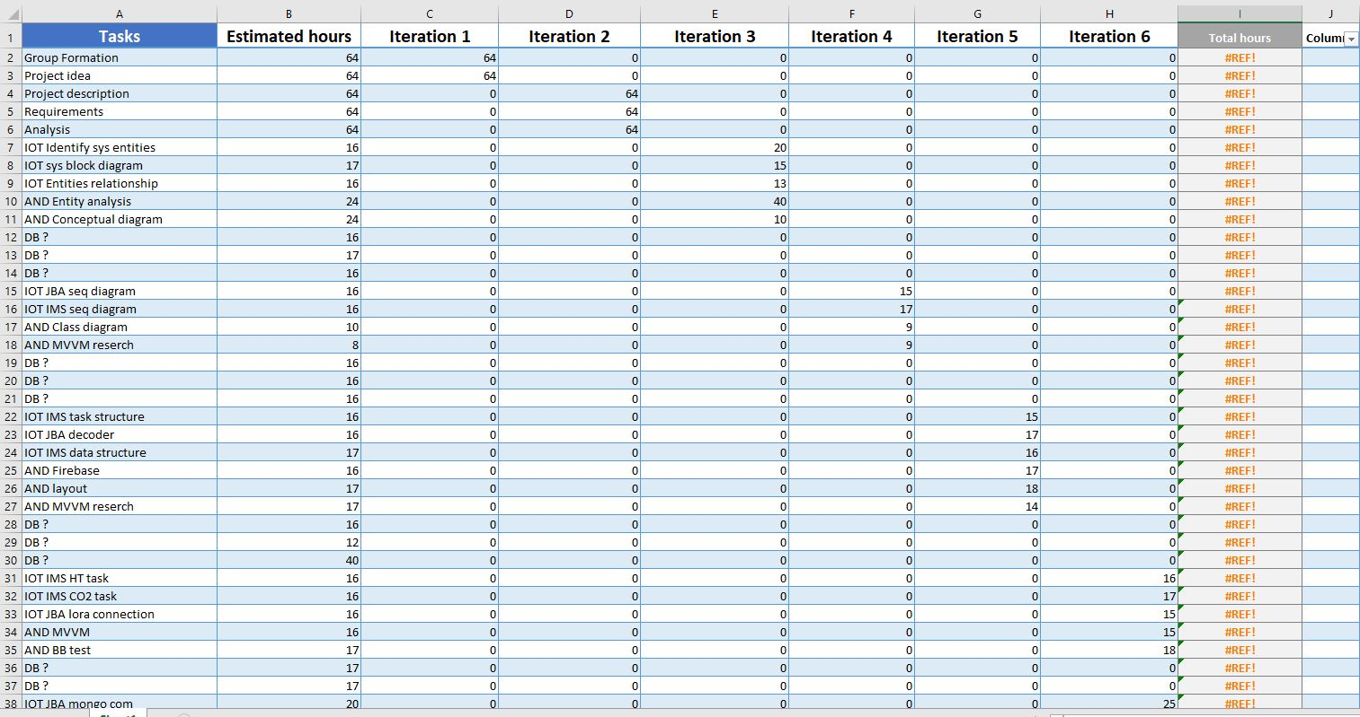

The data from the table above have been used to generate the chart shown bellow.

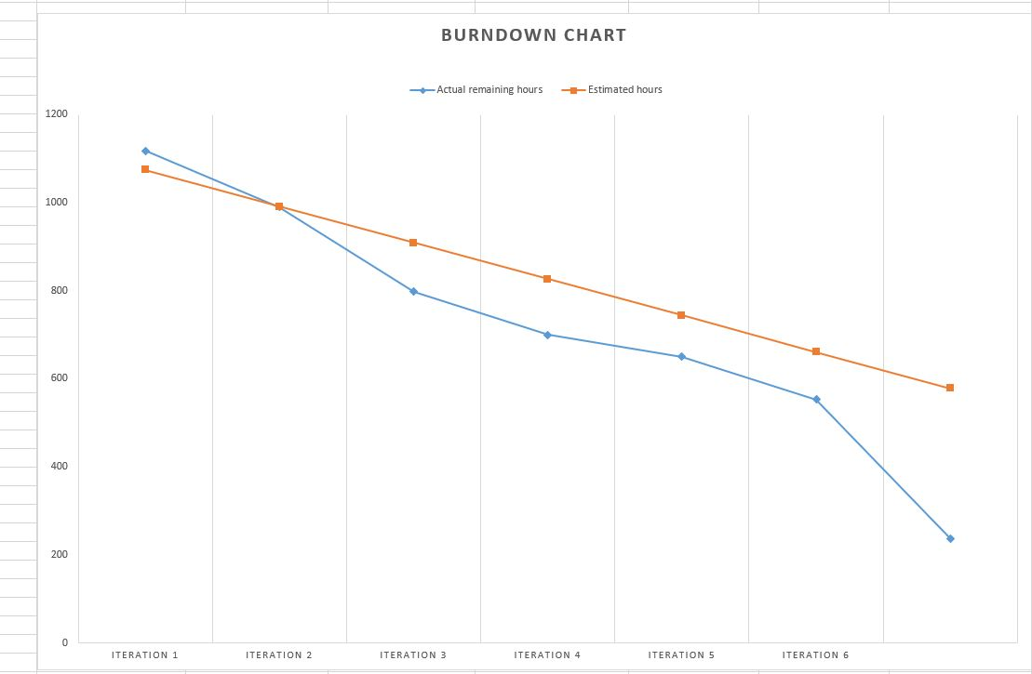

# 6 Personal Reflections

## 6.1 Android Team

Alexandru Vieru:

As a member I was disappointed on how the whole team collaboration worked. People where not showing up for meetings or showing up one or two hours late .

This project was given a strict time schedule to complete and would have succeeded to a higher extent if people would have not neglected their responsibilities.

A plan has been made in the beginning which split the work across multiple sprints and was structured so that all the tasks would be completed before the deadline.

In the beginning of the project everything seemed to work well, people where showing up for the scheduled meetings , but further down into the project when the actual design began, some groups where starting to neglect their responsibilities which drastically decreased our productivity and put us behind schedule.

We had to remove one of our members from the group, since this person has been given many opportunities to work with us, but unfortunately, he decided to ignore the plan completely and not care about if this project would succeed or not.

By dismissing him we lost a group member, and as such certain delimitations had to be made in the project. Certain functionalities for the app had to be removed.

We hope that in the future that these events will not happen anymore and if they do actions will be taken sooner than before.

Rares Bunea:

Working in the Android team with my colleague, Alexandru, was a pleasure for myself. We had a good collaboration and we finished a consistent amount of the tasked we had planned ahead without exterior help.

Sadly, we got parts for our overall system way too late than expected and in the rush of trying to implement them in the very short timespan we had left, we failed with some of them. This was disappointing, since the idea of our system and its design were interesting for me.

Regarding the overall team of our semester project, we did not have a proper team. We usually met we two other people form the IoT group, but even though we struggled with this project, we had a good time together and we learned from it.

My biggest problem about this project was that, the night before the hand-in, we were presented with a “database”, and asked to do something with it.

## 6.2 IOT Team

Alexandru Mircea Dima:

This project was a great opportunity to get acquainted with low level real time operating systems and the functionality that the FreeRTOS provides. I enjoyed working with timers, semaphores and task management. From a process point of view, there is, of course, room for better.

Ionut Boitan:

Working on this project could have been a good opportunity to achieve great knowledge regarding FreeRTOS, low level task management and operating on bear hardware. With greater involvement, this achievements would have really encountered to a better level, but there is still lot of space for improvements, the possible outcome being clear. Overall the contact with an RTOS was an opening for further investigation and longer working hours. The experience proved again some lacking abilities regarding group work and communication but confirmed the willingness to help.

Liviu Lesan:

The idea of connecting different fields in software development for sure sounded challenging. For completion this challenge it was necessary – responsibility, in order to follow time that have been dedicated. In beginning this characteristic was felt inside of the group when we started generating ideas and making analysis. By the time this feature disappeared for some unknow reasons after we devised in groups following tasks. Furthermore lack of communication we had with DatabaseTeam made us think if we will be able to deliver final product but somehow they managed to deliver their working part. Taking everything in account experience gained from this project outline particular trail that should be followed to succeed in accomplishment projects requirements in given time.

## 6.3 Data Team

Alexandru Ciornea:

For me, this project represented an occasion to learn a lot about Data. With the help of my two other teammates, we, together, managed to solve all the problems and in the end achieve the completion of our part of the system.

However, one thing I did not enjoy very much was the tension and the conflicts created between the members of the other teams. Even if we managed to overcome the delayed delivery of some files and work around them, the biggest problem was the aggressiveness and lack of cooperation from the Android team. Overall, I was pleased with the workflow of my team, especially after splitting up in branches since we were able to work more comfortably, since we chose to work in a more private setting.

Alexandru Mihai Serb:

For me, the member with the highest Data knowledge of the team, this project was easy and challenging at the same time. We have gone over easy and hard tasks successfully and I managed to get knowledge on some subjects I didn’t know before. I enjoyed working with the Data team as we successfully agreed on many meetings at the University or at home and we managed to deliver what was expected from us within the time limit.

Even if we encountered difficulties on the communication side with the Android team, overall, we were in good relations with the rest of the teammates and managed to cooperate with them.

Raul Pologea:

The project had a good and promising start. After creating and meeting all the new teammates we set up a set of rules and decided what was our next step. However, as the project carried on, we encountered various difficulties with the other sub-teams and teammates. From people showing up extremely late to the meetings to other teams not showing up at all, resulting in various setbacks and delays.

One other problem we had to deal with was the pauses and breaks during the project and the fact that some teams such as the Data team took fewer, medium-length breaks and other teams took many long breaks such as coffee or cigarette breaks. However, after splitting into branches that problem was eliminated, and our team could work at full efficiency.

The overall project carried our fine, taking into consideration the difficulties caused by the Cross-Media team, and I hope that in the future the process will be more fluid.

# 7 Supervision

Our supervisors were helpful. We went to them for advice on how to design our project and help us better understand the connections between classes and how the code should be implemented. However, we wished that at certain points we could have gotten more help since many times we struggled with our coding and could not get any support.

# 8 Conclusions

Generally, based on the project execution phase and our personal reflections, the group agreed that the work could have been way better. From the forming phase till the delivery, difficulties have been encountered, so that the group struggled with meeting the requirements to be able to deliver an working project. Being stuck in storming and norming phases( according to Tuckman model) most of the times.

During the whole period allocated for the project, the team was not able to successfully implement SCRUM, and an UP approach has followed. The project crossed through most of the UP phases, not reaching the transition phase and testing in a framework not being done. During the development, small testing have been done, many times the trial and error approach being the only suitable approach.

Reflecting on the requirements for the business case established as team work in the analyzing phase, together with the project requirements, it can be concluded that 60-70% of it has been completed.

In final phase the project is able to measure habitat conditions, prepare and upload the data on the LoRiot server from where the Java bridge was able to receive and decrypt the data.

The transmission to a MongoDB database has been successfully done so that the data to be sent further to an SQL Server where a DataWarehouse should have handled it.

Not having available data from the SQL server in due time and being less members than considered in the start, the Android team was able to manage presenting fake data to users who could have access to the data. Creating and managing users accounts in Firebase by an administrator has also been achieved.

Many hours have been spent for this report and at times this became exhausting but at the same time, this improved our skills in our line of work.

Overall all these factors contributed in producing an outcome and made the rest of us improve in certain aspects of our education.